**DAILY ONLINE ACTIVITIES SUMMARY**

|  |  |  |  |  |  |  |  |  |
| --- | --- | --- | --- | --- | --- | --- | --- | --- |
| **Date:** | **18/06/2020** | | | | | **Name:** | **AKASH S** | |
| **Sem & Sec** | **4TH&A** | | | | | **USN:** | **4AL18CS004** | |
| **Online Test Summary** | | | | | | | | |
| **Subject** | | **-----** | | | | | | |
| **Max. Marks** | | **--** | | **Score** | | | **--** | |
| **Certification Course Summary** | | | | | | | | |
| **Course** | **INTRODUCTION TO INFORMATION SECURITY** | | | | | | | |
| **Certificate Provider** | | | **GREAT LEARNING** | | **Duration** | | | **5.5 HOURS** |
| **Coding Challenges** | | | | | | | | |
| **Problem Statement 1: Write a C Program to generate first N Magic Numbers.**  **Problem Statement 2:Find the smallest positive integer value that cannot be represented as sum of any subset of a given array sorted in ascending order.** | | | | | | | | |
| **Status: executed** | | | | | | | | |
| **Uploaded the report in Github** | | | | | **YES** | | | |
| **If yes Repository name** | | | | | <https://github.com/akashacharya786/lockdown-c-coding>  **https://github.com/akashacharya786/lockdown-java-coding** | | | |
| **Uploaded the report in slack** | | | | | **YES** | | | |

**Online Test Summary:** NOT CONDUCTED.

**Online Certification course:**

Today I have started a new course

Name of the course : Introduction to information security

Duration: 5.5 hours

Certificate provider: great learning

Snap shot:

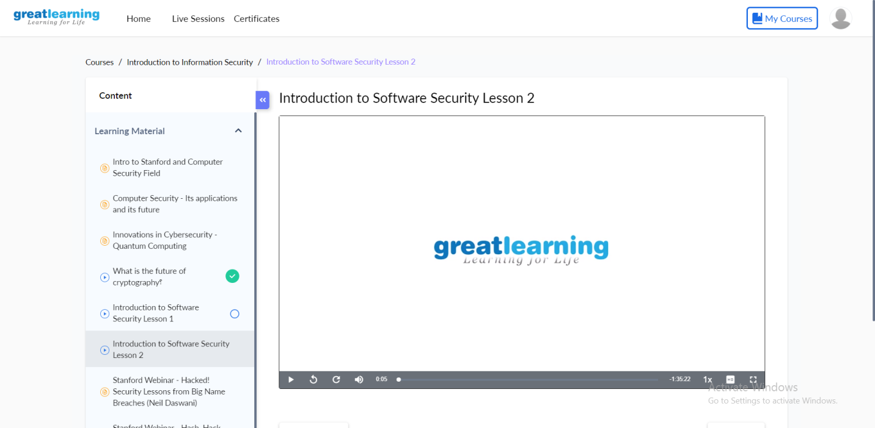

In today I learnt about

* What is the future of cryptography
* Introduction to software security

Online Coding summary:

1.  **Write a C Program to generate first N Magic Numbers.**

**Snap Shot:**

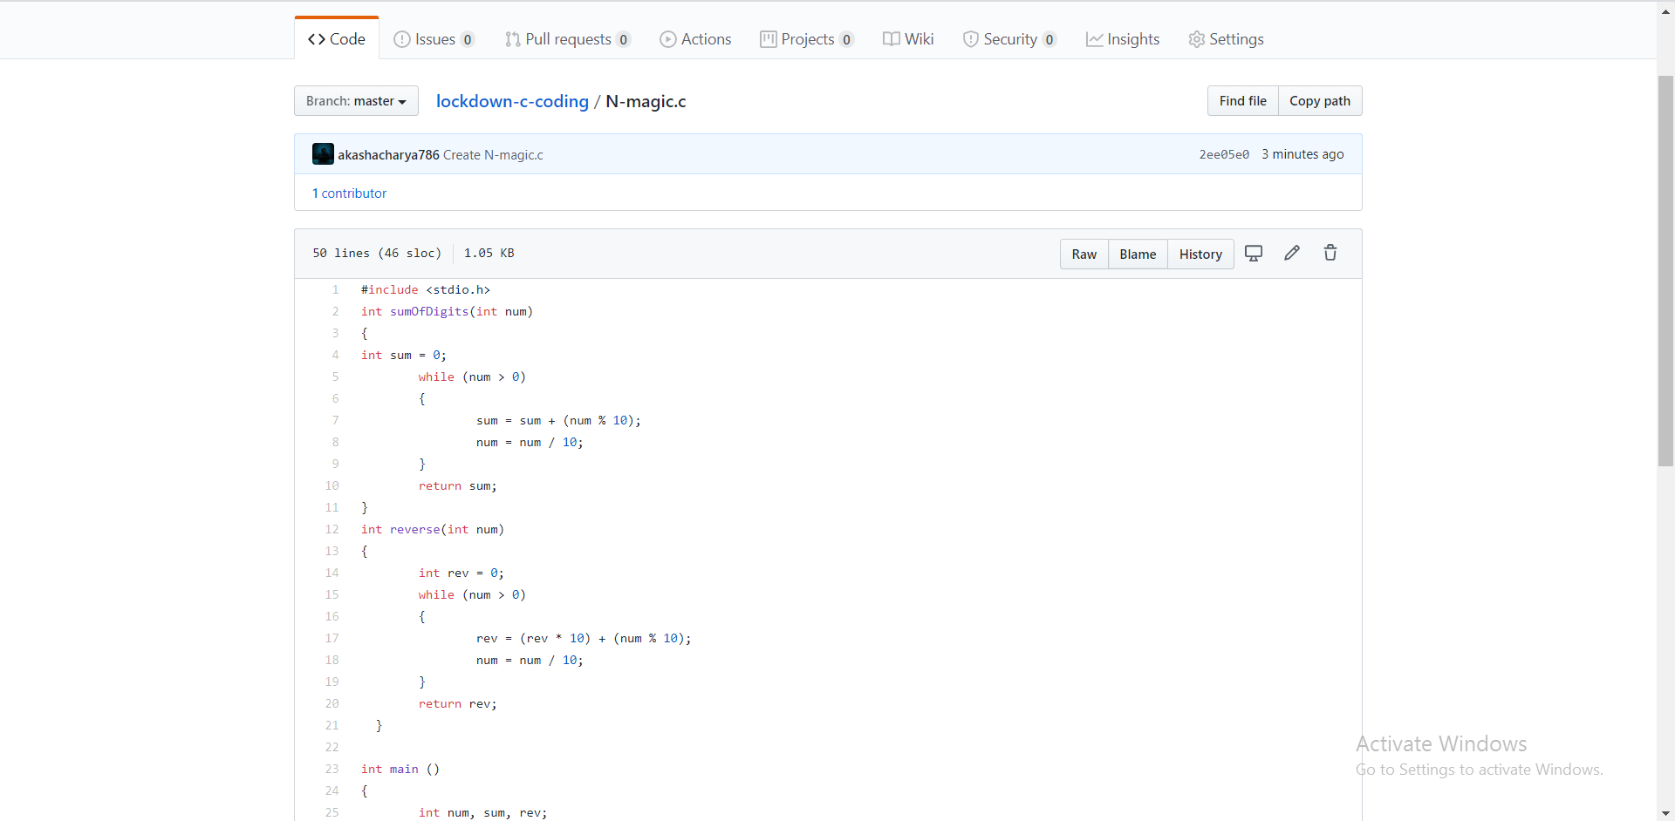

**2. Find the smallest positive integer value that cannot be represented as sum of any subset of a given array sorted in ascending order.**

**Snap Shot:**

